Relax Inc. Challenge

This dataset was highly unbalanced (~10:1 ratio). Also, the data did not allow for a useful model to be trained. Below are the ROC curves for the best models:

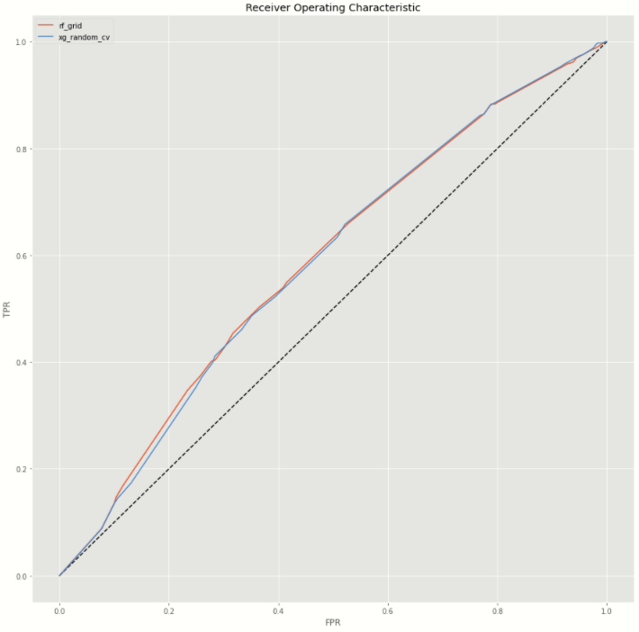

I tried different methods of over-sampling and under-sampling, but this did not improve the model at all.

I conclude that, for a business case where the need of predicting adopted users is for targeting ads to those that will not be adopted, a model would be just as good as assuming all users to be 0s (not adopted). Therefore, I suggest a cheap ad campaign to send to all new users regardless.